4COSC0010C Software Development II

Final Lab-based Assessment 24/25
PROJECT Case Study

Before you start reading this, please read the test instructions very carefully.
This document provides additional information which you may find useful.

The Parking Lot Reservation App
In this assessment, you will work on a project called 4COSC010C_ParkingLotApp, which is a project to manage a small parking lot.
This project has one main file called App.java. You can download, unzip, and open the project using IntelliJ. The App.java file can be found inside the src folder.
Once you have loaded the project, you will see that the main file is the class App, which contains several methods and a global variable. More details on these are given below. A description of the code has also been included as comments in the project.

MAIN
The main() method of the class App contains a welcome message to the user, initialises the parking zones and slots for the parking lot, and runs the main menu.

ZONES AND PARKING STRUCTURE
The class App has one global variable called parkingStructure, which is a multi-dimensional array (2D) of type int.
The Parking Lot currently has two distinct parking zones:
- Compact Zone (Zone A): 10 compact-sized parking slots.
- Standard Zone (Zone B): 14 standard-sized parking slots.
These zones are initialised using the initialiseZones() method, which is called at the beginning of the program from the main() method.
Each slot is initially set to a value of 0, which represents that it is currently unoccupied. If a vehicle reserves the slot, the value is updated to 1 to indicate occupied status.
Example Status:
Zone A: 0001000000 → Slot 4 (index 3) is occupied, all others are available.

MENU
At the start of the program, the following menu is visualised in the output window:
Welcome to the Parking Lot App!
+----------------------------------------+
| MAIN MENU |
+----------------------------------------+
| 1) Reserve a parking slot |
| 2) Show parking area and available |
| slots |
| 3) Add Zone |
| 4) Register Vehicle Owner |
| 5) Save reservation data to file |
| 0) Quit |
+----------------------------------------+
Please select an option:

This is done when the main() method calls the runMenu() method.
The runMenu() method uses the getOption() method to show the user the options and get the option that the user has selected (using the keyboard).
The runMenu() method will check if the option is valid and call the correct method based on the user’s selection.
The menu will repeat until the user selects option 0 (quit).

RESERVE SLOT METHOD
The reserveSlot() method asks the user to enter a zone letter and a slot number, and checks if the slot is available.
If the slot is available, it will mark the slot as taken (not available) and print the message: “Reservation successful”.
If the slot is not available, it will print the message: “This slot is already reserved”.

SHOW PARKING AREA METHOD
The showParkingArea() method displays the parking structure in a grid-like format, helping users quickly identify which slots are free and which are occupied.

Example: After reserving a few slots, the parking area is displayed as:
+===================================================================+
| PARKING LOT STATUS |
+===================================================================+
| Zone A (Compact): Slot 01 [O] Slot 02 [O] Slot 03 [X] ... Slot 10 [O] |
| Zone B (Standard): Slot 01 [O] Slot 02 [O] Slot 03 [O] ... Slot 14 [O] |
+===================================================================+
LEGEND: [O] = Slot Available [X] = Slot Occupied
+===================================================================+

ADD ZONE
The method addZone() is given but has not been implemented.

REGISTER VEHICLE OWNER
The method registerOwner() is given but has not been implemented.

SAVE TO FILE METHOD
The method saveToFile() is given, but the implementation is not complete.
This method will open a file called ParkingData.txt in the main project directory and will write the word “Data:” in the file. Then it closes the file and prints the message “Data saved to file”.
The implementation of this method is not completed.

RUN THE PROJECT ON INTELLIJ
Make sure you can see the menu in the IntelliJ output window when running the project.
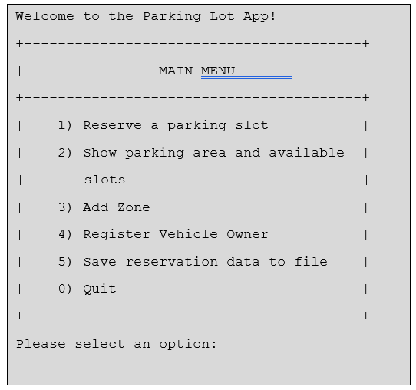

- END-

